6A^{th} Grade: Unit 4, Lesson 2

- What is the name of the point (0,0)?

The Origin

- Write the ordered pair that represents the point after moving 5 units down vertically from the origin.

(0,-5)

- In which quadrant would the point (-1,-1) be located?

Quadrant III

- What scale does the coordinate plane use?
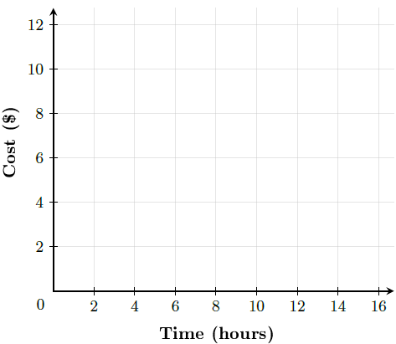

2

- Which ordered pair has the smallest x-coordinate: (-4,5) or (1, 3)?

(-4,5)

- Which ordered pair has the smallest y-coordinate: (0,7) or (1, 2)?

(1,2)

